Course Description: |  | Art 1 is a basic course that provides a foundation for additional art courses that follow. This course is primarily devoted to providing systemic presentation of various art processes, theories, and historical developments. This course is a studio type class, meaning the majority of class time is making art! The focus of the course is experimenting with a variety of dry media. Students will become proficient in this dry media and prepared to take future art classes.  Students in Art 1:  Introduced to the Visual Elements of Art and Principles of Design  Draw from direct observation daily/weekly  Proficiency in basic one and two point perspective  Become accomplished using graphite and charcoal media  Achieve value/3d effect on a 2d surface  Complete a large drawing of a Still Life in charcoal  Complete a large drawing of a Portrait in charcoal  Color Theory using and oil pastel, colored pencils  Exposure to 3d sculpture with clay and design  Pen, watercolor and lino-cut are possible media we will explore  Introducing diverse Contemporary and Modern Artists  Collaboration with peers and teacher  Critique own artwork and peers
Classroom Management Plan: |  | Classroom Management Plan  - Verbal reprimand  - Conference with student with parent contact  - Withdrawal of privilege(s) with parent contact  - Other consequences determined to be reasonable and appropriate by the school administration.  Cell Phones: Cell phones and earbuds/headphones will not be allowed to be used during classroom instruction time. Phones and earbuds/headphones will be put away in a location designated by the teacher and placed in silent mode. In secondary schools, students will have access to their phones and earbuds/headphones outside of classroom instruction time such as between classes and lunch. Failure to follow these procedures will result in a disciplinary referral to the office.
Grading Policy: |  | Grading Policy:  Formal Assessment: 70% Projects  Example of a general Rubric:  Craftsmanship 25%  Effort/Time Management 25%  Execution of the medium at hand 25%  General understanding of the learned concept 25%  ***Each Project will have a specific Rubric that is followed. Students are expected to fill out/grade themselves according to the Rubric and write a Reflection.  Daily Progress: 30%  Consist of class participation, staying on task, and giving your best effort!  Weekly observational drawing assignments that are completed in sketchbook for a grade.  Contemporary Artists-weekly assignments will be graded on effort and completion.  ***Projects and assignments have due dates and are expected to be completed on time. A zero will be entered after the due date and will be updated once the project or assignment is completed.  I have high expectations for each and every student!!
Make-up Work Policy: |  | Homework/Classwork: Students who are absent for excused reasons will be permitted to make up missed work. It is the student’s responsibility to get their work assignments the day upon return to school and complete the assignments according to a time frame determined by the teacher within two weeks of the date of the last absence. Grades of zero will be assigned for assignments missed because of unexcused absences.
Materials and  Supplies Needed:  Laptops  Accommodations |  | Class Materials:  Sketchbook-spiral bound, medium size - 9x12  Pencils and extra erasers  (Find at Target, Hobby Lobby, Michael’s, WalMart, Staples, Office Depot, Amazon)  (Optional and greatly appreciated: Kleenex, clorox wipes)  Example of Sketchbook below: (Some sketchbooks even say Drawing-great too!)  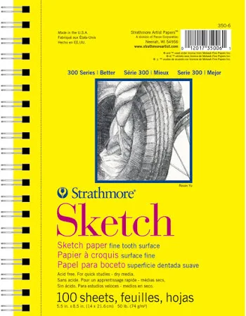  $25 class fee paid online or at fee office  Concerning laptop utilization: 1.Student laptops should not be hard-wired to the network or have print capabilities. 2. Use of discs, flash drives, jump drives, or other USB devices will not be allowed on Madison City computers. 3. Neither the teacher, nor the school is responsible for broken, stolen, or lost laptops. 4. Laptops and other electronic devices will be used at the individual discretion of the teacher.  Requests for accommodations for this course or any school event are welcomed from students and parents.
Example: 18 – WEEK PLAN*
Weeks 1-3 | Elements and Principles of Art/Perspective/Observational Drawing
Weeks 4-7 | Value/Charcoal Still Life/Observational Drawing
Weeks 8-10 | Value/Charcoal Portrait/Clay sculpture
Weeks 11-15 | Colored Pencils/Chalk Pastel
Weeks 16-18 | Mixed Media/Lino-Cut
Week 19 | Review for Final

*This is a tentative plan and may change at the discretion of the teacher.

Please sign below to acknowledge that you have received, read, and understood the syllabus.

Student name: ___________________________________

Student signature: __________________________________

Parent/guardian name: ____________________________

Parent/guardian signature: ____________________________

Parent/guardian, please provide two ways for me to contact you (email address, phone numbers):

Parent/guardian Email:

__________________________________________________________________________________________

Parent/Guardian Phone number:

__________________________________________________________________________________________

Additional Comments:

